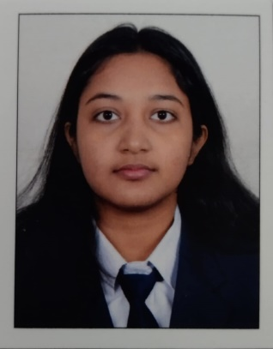**Curriculum Vitaé**

**Name:** Suditi Bera

**Address:** A.T Ghosh Road, G.I.P Colony, Jagacha, Howrah-711112

**Mobile No:** 8100057097

**E-mail:** [suditi.ptbab@gmail.com](mailto:suditi.ptbab@gmail.com)

**Academic Qualification**

|  |  |  |  |  |  |  |
| --- | --- | --- | --- | --- | --- | --- |
| Degree  /Certificate | Degree | Discipline | Institute | Board  /University | Year Of  Passing | Aggregate %/ CGPA |
| Graduation | B.Tech | CSE | University Of Engineering and Management, Kolkata | University Of Engineering and Management, Kolkata | 2023 | 8.71( 5th semester) |
| 12th | Higher Secondary | Science | Kendriya Vidyalaya Santragachi | CBSE | 2020 | 62.83% |
| 10th | Secondary | General | Kendriya Vidyalaya Santragachi | CBSE | 2018 | 87.40% |

**Trainings/Projects Undertaken**

|  |  |  |
| --- | --- | --- |
| Name Of Institute/Organisation | Project Tittle | Duration |
| University Of Emgineering and Management, Kolkata | Bloggify:  (A blog writing website.) | 16 weeks |
| University Of Emgineering and Management, Kolkata | Project Guru:  (A website for project management.) | 19 weeks |
| University Of Engineering And Management, Kolkata | Indie Hues:  (A shopping portal) | 24 weeks |

**Additional Qualification / Achievements / Certifications:**

* Coursera courses certification.
* University IOT Workshop attended.
* NEN Workshop for Entrepreneurship.
* Course on cyber security certification
* University Google Cloud Workshop attended.
* University Workshop on Arduino attended.
* Google Cloud skill badges earned.

**Subjects of Interest:**

* HTML, CSS
* DBMS
* Data Structure And Algorithms
* SQL

**Programming Language Proficiency:**

* Java

**Hobbies:**

* Making Art (Painting, Sketching, Crafting)
* Reading Novels (especially Fiction)
* Writing
* Singing, playing musical instruments e.g., Ukulele, Piano, Harmonium

**Family Details:**

|  |  |  |
| --- | --- | --- |
| Details | Name | Occupation |
| Father | Sujit Bera | Private Sector |
| Mother | Supriti Bera | House-Wife |
| Siblings (Brother) | Divya Bera | Student |

**Personal Details:**

**Date of Birth:** 18.11.2001

**Gender:** F

**Languages Known:** Hindi, Bengali, English, Sanskrit, German

**Date:** 06.01.2023